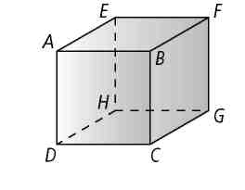**Name _______________________________**

**Use the cube to name each of the following.**

**1.** all lines that are parallel to

**2.** a pair of parallel planes

**3.** two lines that are skew to 

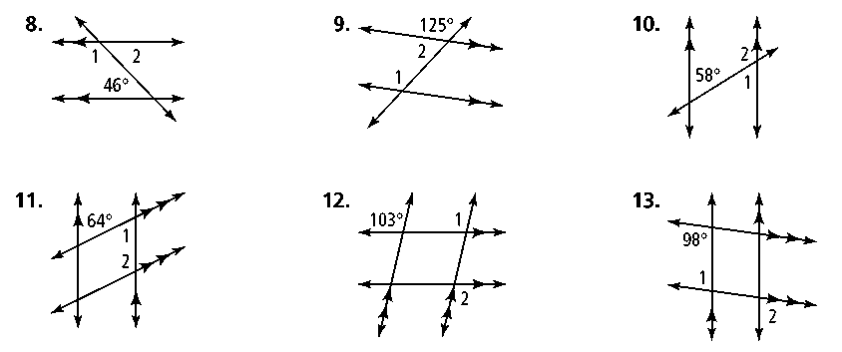**Find *m*∠1 and *m*∠2. State the theorems or postulates that justify your answers.**

**4. 5. 6.**

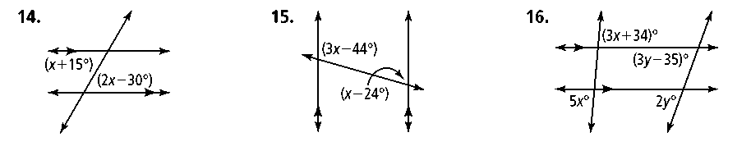**Find the value of each variable. Then find the measure of each labeled angle.**

**7. 8. 9.**

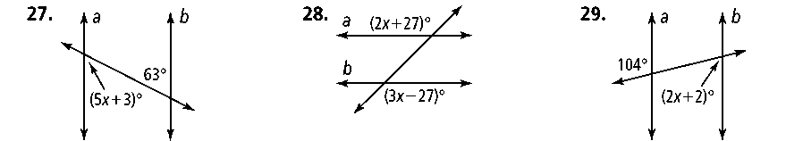**Find the value of *x* for which *a ||* *b*.**

**10. 11. 12.** 



**Given:** ∠1 is supplementary  
 to ∠2

**Prove:** 

**13. Complete the flow proof.**

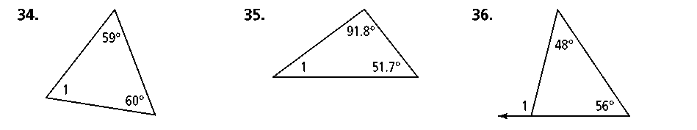**Find m∠1.**

**14. 15. 16.**

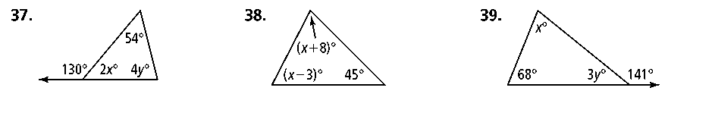**Find the value of each variable.**

**17. 18. 19.**

**Use the given information to write an equation of each line.**

**20.** slope −4, *y*-intercept 6 **21.** slope 7, passes through (1, −2)

**Write an equation in slope-intercept form of the line through the given points.**

**22.** *P*(0, 2), *Q*(6, 8) **23.** *K*(5, 0), *L*(−5, 2)

**Without graphing, tell whether the lines are parallel, perpendicular, or neither. Explain.**



**24. 25. 26.** *y* = –2*x* + 7

*x –* 2*y* = 8

**Write an equation for the line parallel to the given line through the given point.**

**27.** *y* = *x −* 7, (0, 4) **28.** 

**Write an equation for the line perpendicular to the given line through the given point.**

**29.** *y* = *x +* 2, (3, 2) **30.** 