Name _________________________________ Date ___________________
Side-Splitter Theorem | If a line is ____________________ to one side of a triangle and intersects the other __________ ________________, then it divides those sides _____________________________.  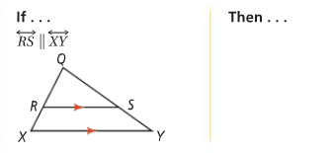
Problem 1 | What is the value of x?  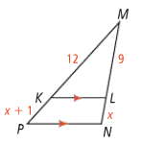
Corollary to the Side-Splitter Theorem | If _____________ ___________________ lines intersect __________ ___________________, then the segments intercepted on the ___________________ are ___________________________.  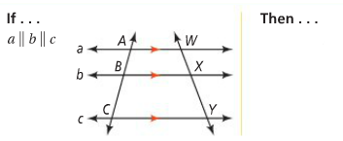
Problem 2 | 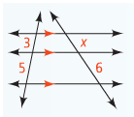  Find the value of x.
Triangle-Angle-Bisector Theorem | If a ________ bisects an ____________ of a triangle, then it divides the _________________ ______________ into __________ segments that are __________________________ to the other ________ sides of the triangle.  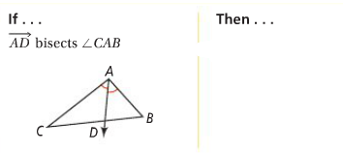
Problem 3 | What is the value of x?  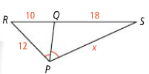
Problem 4 | Find the value of x.  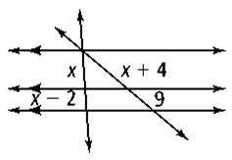
APPLICATION
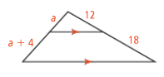
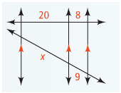
Solve for the variables.
1. 2.

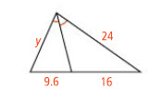
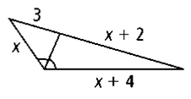
3. 4.

