Name

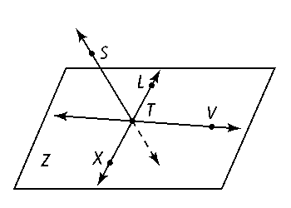Class

Date

**Use the diagram at the right for Exercises 1–3. Note that in this diagram ** pierces the plane at *T.* The point *S* is not contained in the plane.**

**1.** What is another name for plane *Z?*

**2.** Name two opposite rays in the diagram.

**3.** Where would the plane *STL* intersect plane *Z?*

**Use the figure below for Exercises 4–6.**

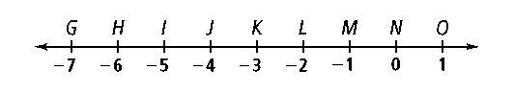

**4.** Name two points that are 4 units from *K.*

**5.** Name a segment congruent to **.

**6.** Name the coordinate of the midpoint of *.*

**7.** Point *M* is the midpoint of $\overline{LN}$. What is *LM*?

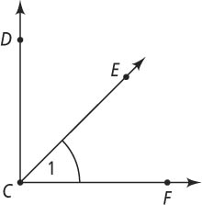**Use the figure at the right for Exercises 8–11.**

**8.** What are two other names for ∠1?

**9.** If *m*∠*DCF* = 90, classify each as right, straight, acute, or obtuse.

**a.** ∠*DCF* **b.** ∠*DCE*

**10.** If *m*∠*DCF =* 90, *m*∠*DCE =* 3*x +* 12, and *m*∠*FCE =* 4*x +* 1, find the value of *x.*

**11.** Are ∠*DCE* and ∠*ECF* vertical, complementary, or supplementary angles, if *m*∠*DCF =* 90?

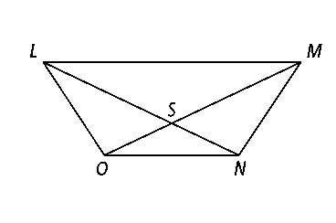**Use the figure at the right for Exercises 12–15.**

**12.** Name a pair of vertical angles.

**13.** Name a pair of adjacent angles with vertex *M.*

**14.** Name a pair of adjacent angles with vertex *S.*

**15.** Name a linear pair.

**16.** ** bisects ∠*DGH* so that *m∠DGI* = *x –*3 and *m∠IGH* = 2x –13. What is *x?*

**17. ∠**1 and **∠**2 are supplementary angles. *m*∠1 = 4*y* **+** 7 and *m*∠2 = 9*y* **+** 4. What is *m*∠2?

**18.** has endpoints *F*(−2, 3) and *R*(1, 1). What are the coordinates of its midpoint?

**19.** The midpoint of ** is (5, —11). One endpoint is *S*(3, 5). What are the coordinates of endpoint *M?*

**20.** What is the distance between points *M*(6, –16) and *Z*(–1, 14), to the nearest tenth?

**21. Compare and Contrast** How is naming a line segment different from naming a line?