Composition of Reflections | A composition of reflections across two A composition of reflections across two  _______________________________ _______________________________  _______________________________ _______________________________  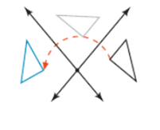  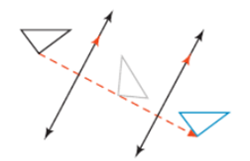
Problem 1 | 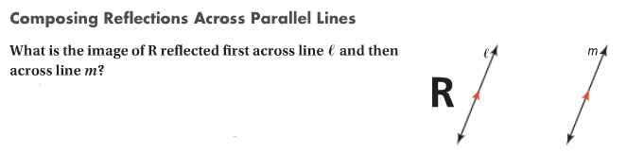
Problem 2 | 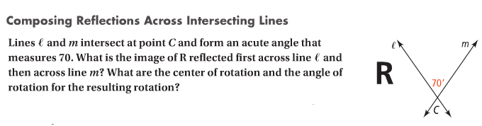
Glide Reflection | ____________________________________________________________  ____________________________________________________________  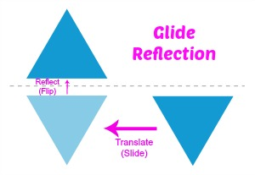
Problem 3 | 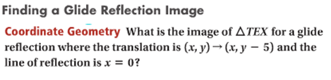  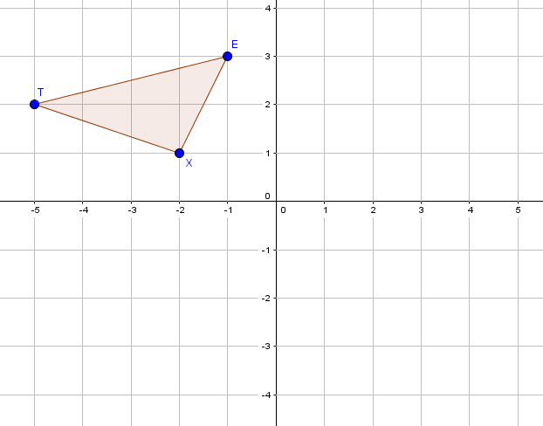

APPLICATION
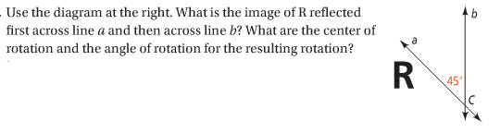
1.

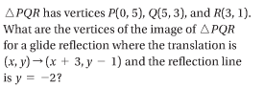
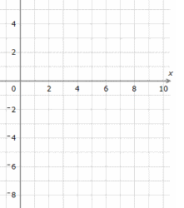
2.

