Angle of Elevation | The angle of elevation of an object as seen by an __________ is the ______ between the ____________ and the line from the object to the observer's eye.  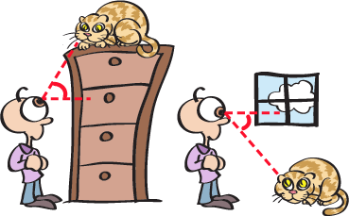
Angle of Depression | If the object is _______ the level of the observer, then the angle between the horizontal and the observer's line of sight is called the _______ ___ _____________.
Problem 1 | Angles of Elevation?  Angles of Depression?  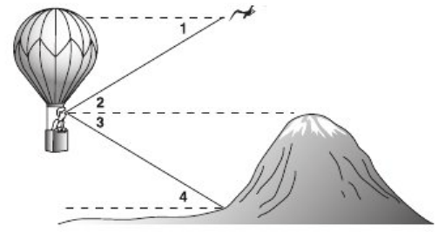
Problem 2 | Find the value of x to the nearest tenth of a foot.  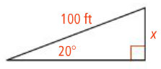  Is this an angle of elevation or depression?
Problem 3 | A blimp provides aerial television views of a football game. The television camera sights the stadium at a 7 degree angle of depression. The altitude of the blimp is 400m. What is the line-of-sight distance from the television camera to the base of stadium? Round to the nearest meter.
Application
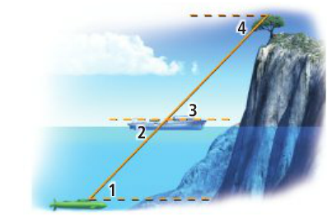
For questions 1 & 2 use the figure at right.

1. Which are angles of elevation?

2. Which are angles of depression?

3. Find the value of x. Round to the nearest tenth of a yard.
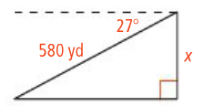

4. A pilot is approaching an airport at a 3 degree angle of descent. The plane is currently 1007 ft. off the ground. To the nearest tenth of a foot, what is the horizontal distance of the plane to the airport?

Comprehension

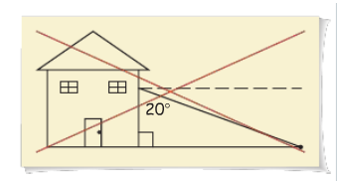
5. A homework question says that the angle of depression from the bottom of a house window to a ball on the ground is 20°. Below is your friend’s sketch of the situation. Describe your friend’s error.

