Review of Trigonometric Functions
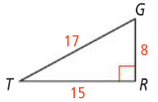
sin T = =

cos T = =

tan T = =

Problem 1 | 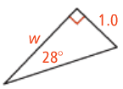
Inverses of Trig. Functions | If you know the ____________ , _______________ , or , ____________ ratio for an angle, you can use an inverse (______, ______, or ______ ) to find the measure of an angles.
Problem 2 | 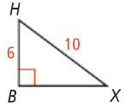
Problem 3 | 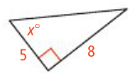

Application

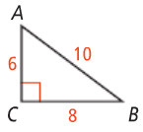
- Write each ratio.

  - sinA =
  - tanA =
  - cosA =
  - cosB =
  - sinB =
  - tanB =

- Find the value of x. Round to the nearest tenth.
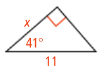

- Find the value of x. Round to the nearest degree.
