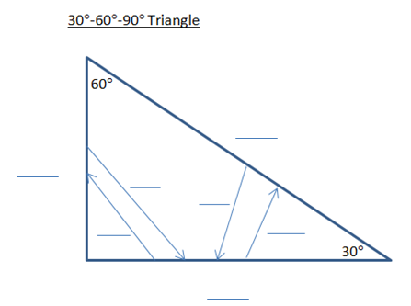
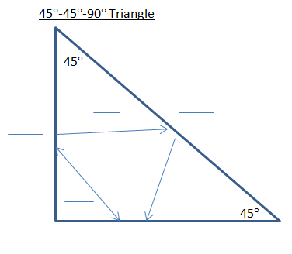

45°-45°-90° Triangle Theorem  (also known as __________ ________ triangle.) | In a 45°-45°-90° triangle, both legs are ___________ and the length of the hypotenuse is ____ times the length of a leg.
Problem 1 | What is the value of h?  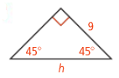
Problem 2 | What is the value of x?  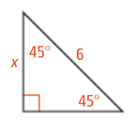
30°-60°-90° Triangle Theorem | In a 30°-60°-90° triangle, the length of the hypotenuse is _______ the length of the shorter leg. The length of the longer leg is _____ times the length of the _________ leg.
Problem 3 | 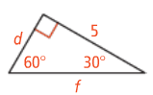  Find the length of sides d and f.

Application

- Find the value of each variable.
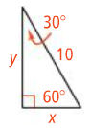

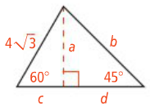
- Find the value of each variable.

- Find the value of each variable.
