The Pythagorean Theorem | If a triangle is a right triangle, then the of the lengths of the legs is equal to the of the length of the .  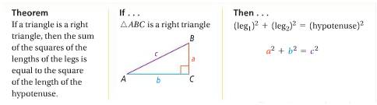
Pythagorean Triples | A set of nonzero whole numbers a, b, and c that satisfy the equation __________________.  Some common Pythagorean Triples include but are not limited to:
Problem 1 | What is the length of the hypotenuse of ΔABC? Do the side lengths of ΔABC for a Pythagorean triple?  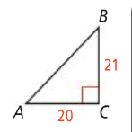
Problem 2 | What is the value of x?  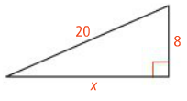
Converse of the Pythagorean Theorem | If the sum of the squares of the lengths of sides of a triangle is to the square of third side, then the triangle is a .  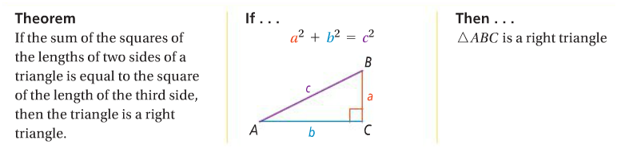
Problem 3 | A triangle has side lengths 85, 84, and 13. Is the triangle a right triangle?
Obtuse Triangles | 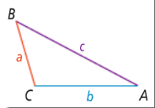  A triangle is obtuse if…  _______________________
Acute Triangles | A triangle is acute if…  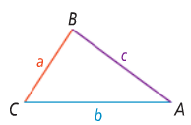  _______________________
Problem 4 | Is a triangle with side lengths 7, 8, and 9 acute, obtuse, or right?

Application

1. What is the value of x in simplest radical form?

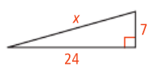

3. A walkway forms on diagonal of a square playground. The walkway is 24m long. To the nearest meter, how long is a side of the playground?

2. What is the value of x in simplest radical form?
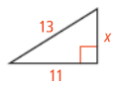

4. A triangle has side lengths 6, 11, and 14. Is it acute, obtuse, or right?

