Angle-Angle Similarity (AA~) Postulate | If _______ _______________ of one triangle are ___________________ to ________ _______________ of another triangle, then the triangles are ________________________.  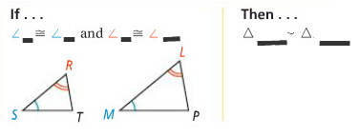
Side-Angle-Side Similarity (SAS~) Theorem | If an _______________ of one triangle is ___________________ to an _______________ of a second triangle and the ___________that include the _______ _______________ are ______________________, then the triangles are ________________________.  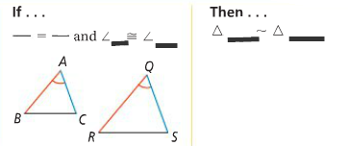
Side-Side-Side Similarity (SSS~) Theorem | If the _____________________ _______________ of two triangles are _________________________, the the triangles are _________________.  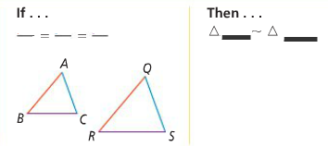
Problem 1 | Determine whether the triangles are similar. If so, write a similarity statement and name the postulate or theorem used.  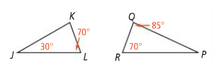  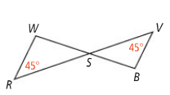  A. B.  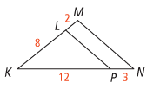  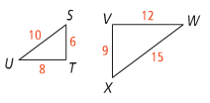  C. D.
Indirect Measurement  Problem 2 | Find the height of the flagpole.  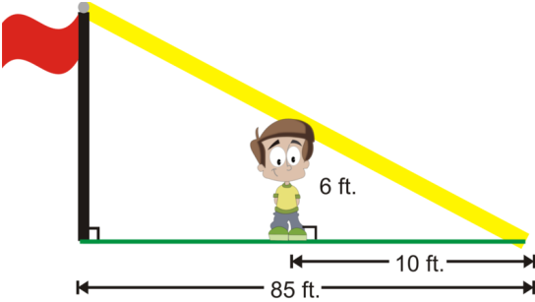
Indirect Measurement  Problem 3 | 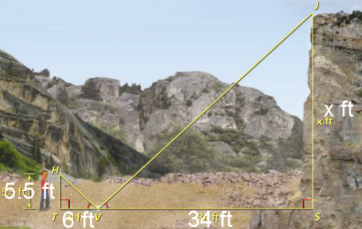
APPLICATION

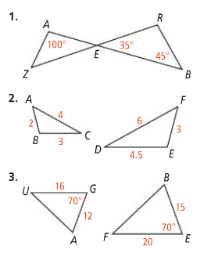

4. At a certain time of day, a 1.8-m-tall person standing next to the Washington Monument casts a 0.7-m shadow. At the same time, the Washington Monument casts a 65.8-m shadow. How tall is the Washington Monument?
?

