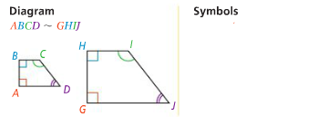
Similar Polygons
Two polygons are similar if:

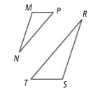
Problem 1
ΔMNP ~ ΔSRT
- What are the pairs of congruent angles?

- What is the extended proportion for the ratios of the corresponding sides?

Problem 2
Are the polygons similar? If they are, write a similarity statement and give the scale factor.
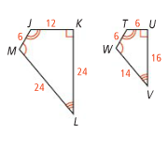
- JKLM and TUVW

- ΔABC and ΔEFD
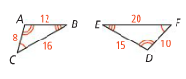

Problem 3
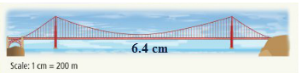
The diagram shows a scale drawing of the Golden Gate Bridge in San Francisco. The distance between the two towers is the main span. What is the actual length of the main span of the bridge?

APPLICATION
- DEFG ~ HJKL
  - What are the pairs of congruent angles?

  - What is the extended proportion for the ratios of the lengths of the corresponding sides?

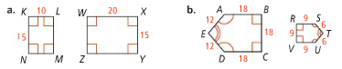
- Are the polygons similar? If they are, write a similarity statement and give the scale factor.

- A cartographer is making a map of Pennsylvania. She uses the scale 1 in = 10 mi. The actual distance between Harrisburg and Philadelphia is about 95 mi. How far apart should she place the place the two cities on the map?

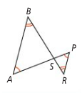
COMPREHENSION
- The triangles at the right are similar. What are three similarity
statements for the triangles?

