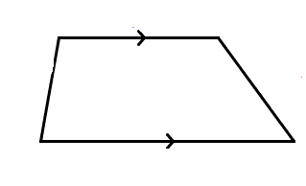
Parts of a Trapezoid

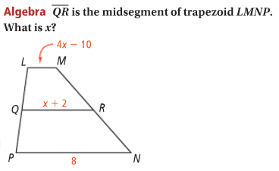
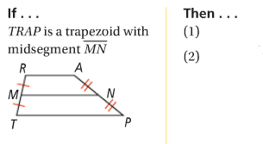
Trapezoid Midsegment Theorem Problem 1

Isosceles Trapezoid Problem 2
In an isosceles trapezoid, What are m∠D, m∠E, and m∠F?
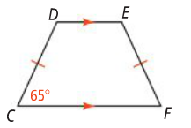
each pair of base ∠s is __________.
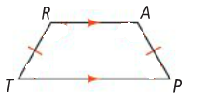

Problem 3 Problem 4
Solve for x. Quadrilateral DEFG is a kite.
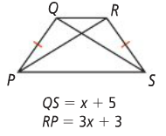
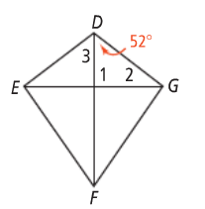
What are m∠1, m∠2, and m∠3?

APPLICATION
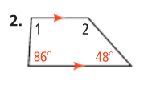
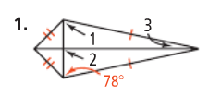
What are the measures of the numbered angles?

3. What is the length of the midsegment of a trapezoid with bases 14 and 26?

PUTTING IT TOGETHER (to be gone over in class)
Name each type of special quadrilateral that can meet the given condition.
1. exactly one pair of congruent sides 2. two pairs of parallel sides

3. four right angles 4. adjacent sides that are congruent

5. perpendicular diagonals 6. congruent diagonals

