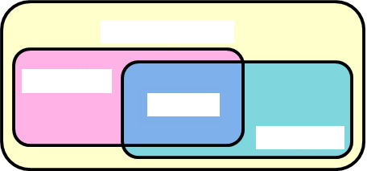

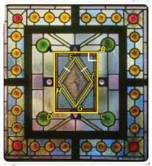
Problem 1
Is parallelogram ABCD a rhombus, a rectangle, or a square? Explain.

Is parallelogram EFGH a rhombus, a rectangle, or a square? Explain.

Problem 2
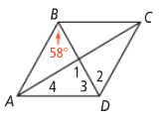
What are the measures of the numbered angles in rhombus ABCD?

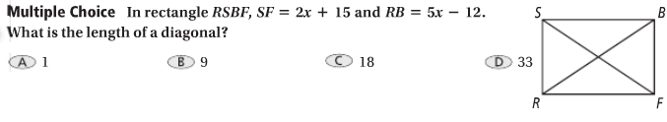
Problem 3

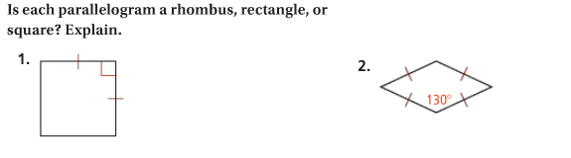
APPLICATION

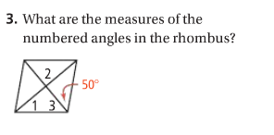

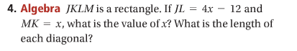

COMPREHENSION
