Name ___________________________________
Key Concept | Notes
Polygon Angle-Sum Theorem
Problem 1 | What is the sum of the interior angle measures of a heptagon?
Problem 2 | 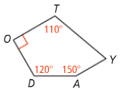  What is m∠Y in pentagon TODAY?
Types of Polygons | 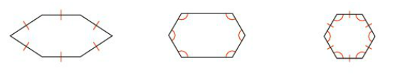
Corollary to the Polygon Angle-Sum Theorem
Problem 3 | What is the measure of each interior angle in a regular hexagon?
Polygon Exterior Angle-Sum Theorem
Problem 4 | What is measure of an exterior angle of a regular octagon?
APPLICATION
1. What is the sum of the interior angle measures of a 17-gon?

2. The sum of the interior angles measures of a polygon is 1980. What is the number of sides in the polygon?

3. What is the measure of each interior angle in a regular nonagon?

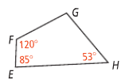
4. What is m∠G in quadrilateral EFGH?

5. What is measure of an exterior angle of a regular nonagon?

COMPREHENSION

6. Draw an equiangular polygon that is not equilateral.

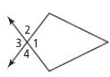
7. Which angles are exterior angles for ∠1?

