Name ___________________________
Key Concept | Notes
Theorem | If _______ _____________ of a triangle are not congruent, then the _______________ ____________ lies opposite the _________________  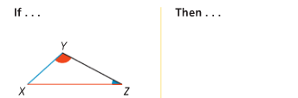  ________________.
Problem 1 | 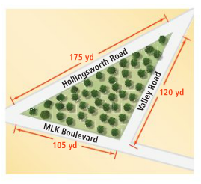  A town park is triangular. A landscape  architect wants to place a bench at the  corner with the largest angle. Which  two streets form the corner with the  largest angle?
Theorem | If _______ _____________ of a triangle are not congruent, then the _______________ ____________ lies opposite the _________________  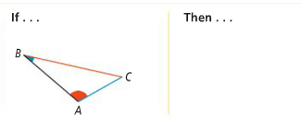  ________________.
Problem 2 | 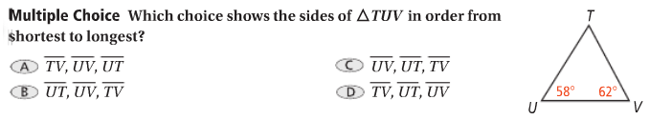
Triangle Inequality Theorem | 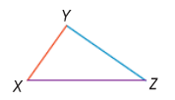
Problem 3 | Can a triangle have sides with the given lengths?  A. 3 ft, 7 ft, 8 ft B. 5 ft, 10 ft, 15 ft
APPLICATION
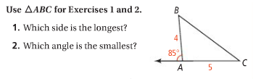

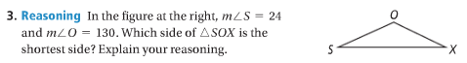

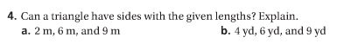

COMPREHENSION
5. A friend tells you that she drew a triangle with perimeter 16 and one side of length 8. How do you she made an error in her drawing?

