Name

Class

Date

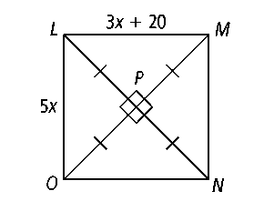

**Use the figure at the right for Exercises 1–4.**

**1.** What is the relationship between  and *?*

**2.** What is the value of *x?*

**3.** Find *LM.* **4.** Find *LO.*

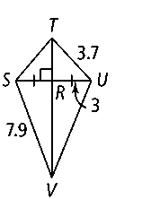**Use the figure at the right for Exercises 5–8.**

**5.** From the information given in the figure, how is  related to *?*

**6.** Find *TS.* **7.** Find *UV.* **8.** Find *SU.*

**9.** At the right is a layout for the lobby of a building placed on a coordinate grid.

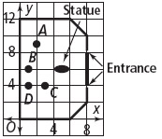

**a.** At which of the labeled points would a receptionist chair be equidistant from both entrances?

**b.** Is the statue equidistant from the entrances? How do you know?

**10.** Prove the Angle Bisector Theorem.

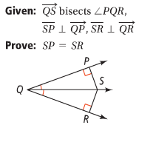

**Use the figure at the right for Exercises 11–15.**

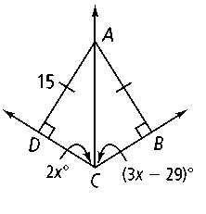**11.** According to the figure, how far is *A* from *?* from *?*

**12.** How is  related to ∠*DCB?* Explain.

**13.** Find the value of *x.*

**14.** Find *m*∠*ACD* and *m*∠*ACB.*

**15.** Find *m*∠*DAC* and *m*∠*BAC.*

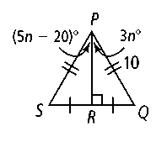

**U**s**e the figure at the right for Exercises 16–19.**

**16.** According to the diagram, what are the lengths of  and *?*

**17.** How is related to ∠*SPQ?*

**18.** Find the value of *n.*

**19.** Find *m*∠*SPR* and *m*∠*QPR.*

**Algebra Find the indicated values of the variables and measures.**

**20.** *x, BA, DA* **21.** *x, m*∠*DEF* **22.** *x, m*∠*DAB*

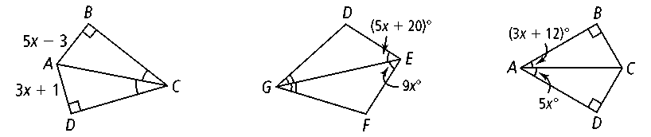

**23.** *m, LO, NO* **24.** *x, m*∠*QTS* **25.** *p, IJ, KJ*

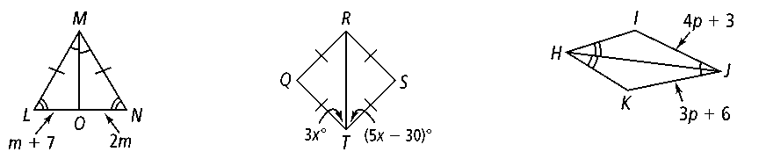

**26.** *r, UW* **27.** *y, m*∠*DEF* **28.** *m, p*

