Name ___________________________
Key Concept | Notes
Perpendicular Bisector Theorem | If a point is on the ___________________ __________________ of a segment, then it is ________________________ from the endpoints of the segment.  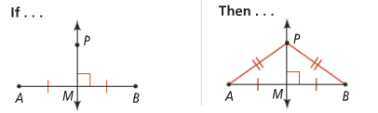
Converse… | If a point is __________________________ from the endpoints of a segment, then it is on the _____________________ _________________________ of the segment.  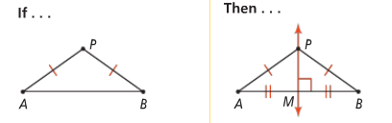
Proof | 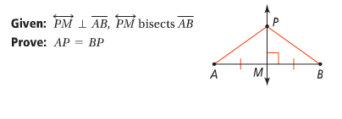
Problem 1 | 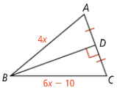  What is the length of $\overline{AB}$?
Angle Bisector Theorem | If a point is on the __________________________ of an angle, then the point is ________________________ from the sides of the angle.  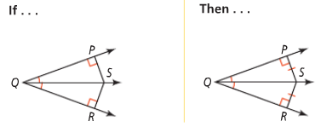
Converse… | If a point in the interior of an angle is __________________________ from the sides of an angle, then the point is on the ____________ _________________ .  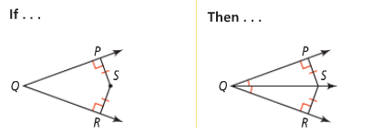
Problem 2 | 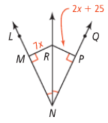  What is the length of $\overline{RM}$?
APPLICATION
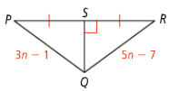
1. What is the length of $\overline{QR}$?

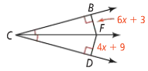
2. What is the length of $\overline{FB}$?

