Name ___________________________
Key Concept | Notes
Midsegment

Triangle Midsegment Theorem | 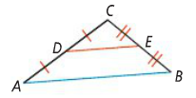  If a segment joins the ________________ of two sides of a triangle, then the segment is:  a)  b)
Problem 1 | 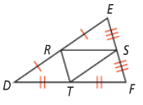  What are the three pairs of parallel segments in ΔDEF?
Problem 2 | In ΔQRS, T, U, and B are midpoints. What are the lengths of $\overline{TU}$, $\overline{UB}$, and $\overline{QR}$?  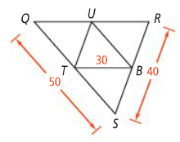
Problem 3 | 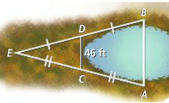  A geologist wants to determine the distance, AB, across a sinkhole. Choosing point E outside the sinkhole, she finds the distances AE and BE. She locates the midpoints C and D of $\overline{AE}$ and $\overline{BE}$ and then measures $\overline{CD}$. What is the distance across the sinkhole?
APPLICATION
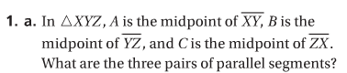
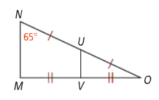

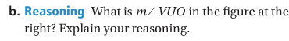

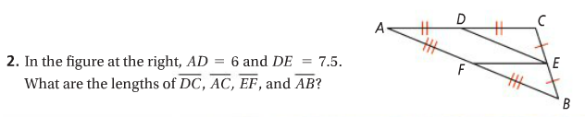

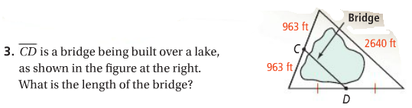

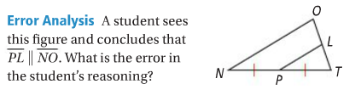
COMPREHENSION
4.

