Key Concepts | Notes
Right Triangles | 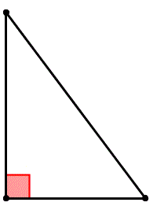
Hypotenuse-Leg (HL) Theorem | If the _____________________ and a __________ of one _______________ triangle are congruent to the ________________________ and a _________ of another _______________ triangle, then the triangles are ____________.
Conditions for HL | 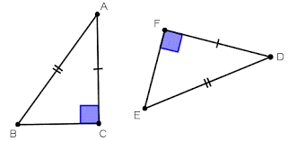
Problem 1 | 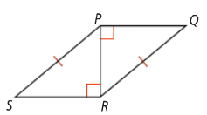  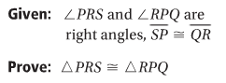
Problem 2 | 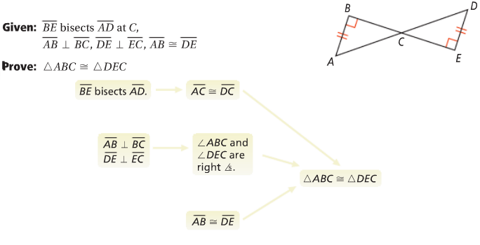
Problem 3 | For what values of x and y are the triangles congruent by HL?  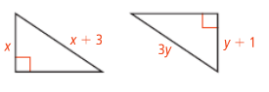
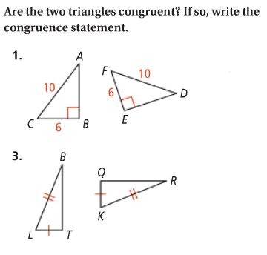
APPLICATION
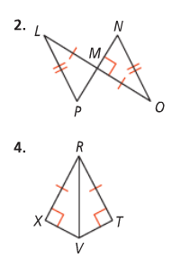

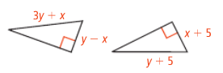
5. For what values of x and y are the triangles congruent by HL?

COMPREHENSION
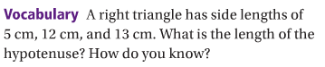
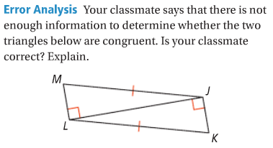
6. 7.

