Key Concepts | Notes
CPCTC
Problem 1 | 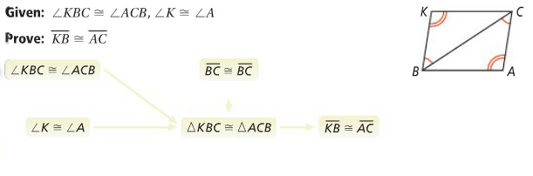
Isosceles Triangle | 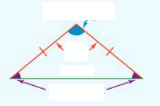
Isosceles Triangle Theorem
Problem 2 | 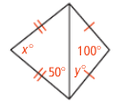  Find the values of x and y.
Theorem | If a line __________________ the ______________________ of an isosceles triangle, then the line is also the _______________________________ ___________________ of the _________________.
Problem 3 | What is the value of x?  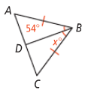
Equilateral Triangle
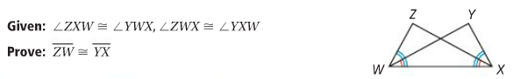
APPLICATION
1
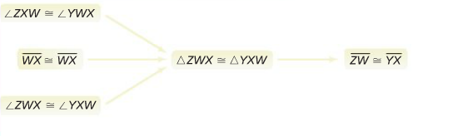

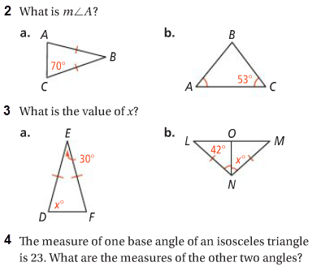

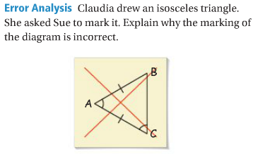
COMPREHENSION
5

