NAME ____________________________
Key Concept | Notes
ASA Postulate | If _______________ ___________________ and the _______________________  ___________of one triangle are congruent to _______ __________________and the ______________________ _____________ of another triangle, then the two triangles are ______________________.  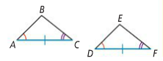
Problem 1 | 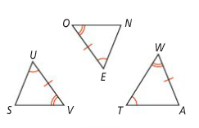  Which of the two triangles are congruent by ASA? Explain.
AAS Theorem | If ___________ __________________ and a __________________________  _______________ of one triangle are _______________________ to _________  __________________ and the ________________________ ________________  of another triangle, then the two triangles are ______________________.  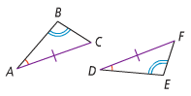
Problem 2 | 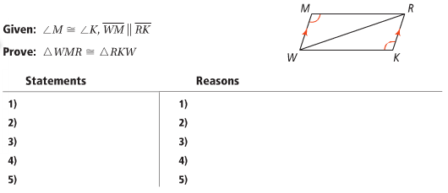
Problem 3 | 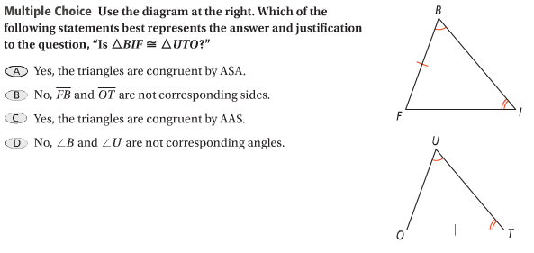
AAA & SSA
Overlapping Triangles  Problem 4 | 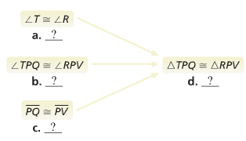  Given: ∠T ≅ ∠R, $\overline{PQ}$ ≅ $\overline{PV}$  Prove: ΔTPQ ≅ ΔRPV  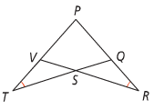
APPLICATION
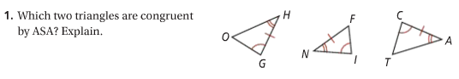

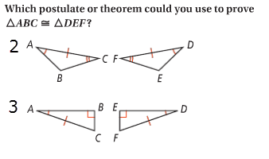
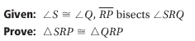
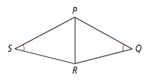
4.

COMPREHENSION
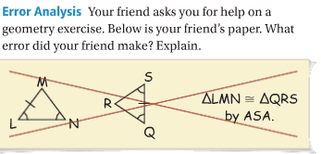
5.

