NAME ____________________________

|  |  |
| --- | --- |
| **Key Concept** | **Notes** |
| **SSS Postulate** | If the _______________ ___________________ of one triangle are ____________ to the _______________ ___________________ of another triangle, then the two triangles are ______________________. |
| **SAS Postulate** | If ___________ __________________ and the __________________________  _______________ of one triangle are _______________________ to _________  __________________ and the ________________________ ________________  of another triangle, then the two triangles are ______________________. |
| **Problem 1** | Given: $\overline{LM}$ ≅ $\overline{NP}$, $\overline{LP}$ ≅ $\overline{NM}$ Prove: Δ*LMN* ≅ Δ*NPL*  C:\Users\JIMCOL~1\AppData\Local\Temp\SNAGHTML570f4070.PNG |
| **Problem 2** | **Would you use SSS or SAS to prove triangles congruent? If so, name the postulate and write a congruency statement. If there is not enough information to prove the triangles congruent, write *not enough information.***  **A. B.**      **C. D.** |
| **Overlapping Triangles**  **Problem 3** | C:\Users\JIMCOL~1\AppData\Local\Temp\SNAGHTML533e44c5.PNG |

APPLICATION

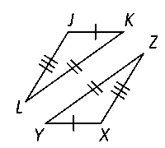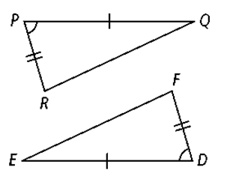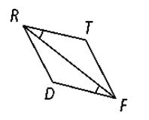**Would you use SSS or SAS to prove triangles congruent? If so, name the postulate and write a congruency statement. If there is not enough information to prove the triangles congruent, write *not enough information.***

**1. 2. 3.**

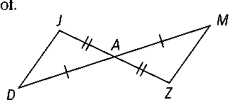**4. Complete the flow proof. 5. Given: $\overline{AE}$ ≅ $\overline{CD}$; ∠*AED* ≅ ∠*CDE***

**Prove: ∆*AED* ≅ ∆*CDE***

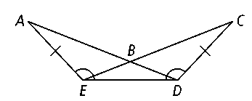**Given:** *, *

**Prove:** ∆*JDA* ≅ ∆*ZMA*

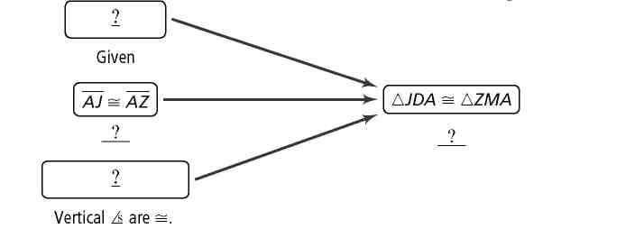

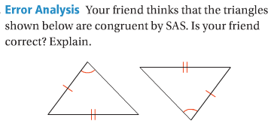COMPREHENSION

**6.**