NAME ________________________
Key Concept | Notes
Polygon
Naming | 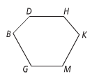
Classifying | Sides Name Sides Name  3 9  4 10  5 11  6 12  7  8 n
Congruent Polygons
Problem 1 | IF HIJK ≅ LMNO, what are the congruent corresponding parts?
Problem 2 | Suppose that ΔWYS ≅ ΔMKV. If m∠W = 62° and m∠Y = 35°, what is m∠V? Explain.
Third Angles Theorem | If ______ _____________ of one triangle are _________________ to ______ ______________ of another triangle, then the _________ __________ are ___________________.
Proving Polygons Congruent | 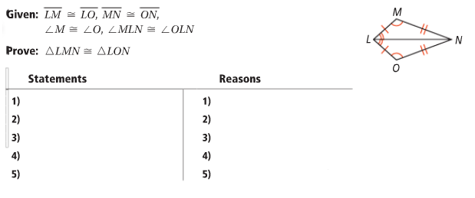
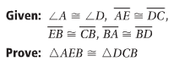
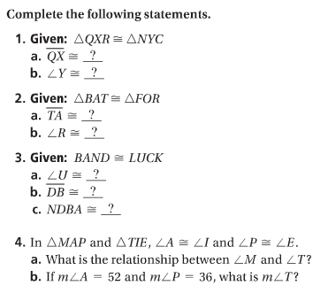
APPLICATION
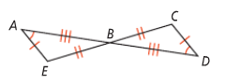
5.

Statements Reasons

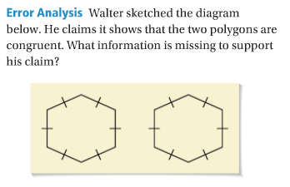
COMPREHENSION
6.

