NAME ________________________
Key Concept | Notes
Slopes of Parallel Lines
Problem 1 | 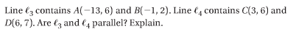
Problem 2 | What is an equation of the line parallel to y = -3x – 5 that contains (-1, 8)?
Slopes of Perpendicular Lines
Problem 3 | 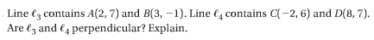
Problem 4 | What is an equation of the line perpendicular to y = $\frac{1}{5}$x + 2 that contains (15, -4)?

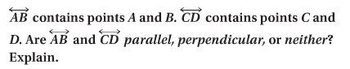
APPLICATION

1. A(-8, 3), B(-4, 11), C(-1, 3), D(1, 2) 2. A(3, 5), B(2, -1), C(7, -2), D(10, 16)

3. A(3, 1), B(4, 1), C(5, 9), D(2, 6)

4. What is an equation of the line parallel to y = -4x + 1 that contains (2, -3)?

5. What is an equation of the line perpendicular to y = -4x + 1 that contains (2, -3)?

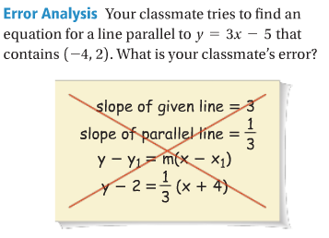
COMREHENSION
6.

