Name

Class

Date

**Find the slope of the line passing through the given points.**

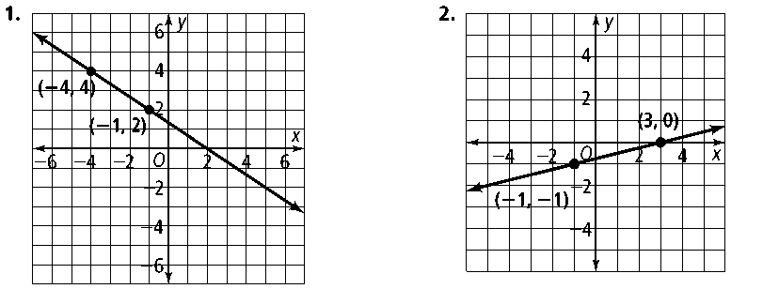**1. 2.**

**3.** (2, 3), (−1, −6) **4.** (−6, −2), (−3, −6) **5.** (2, 9), (4, −7)

**Graph each line.**

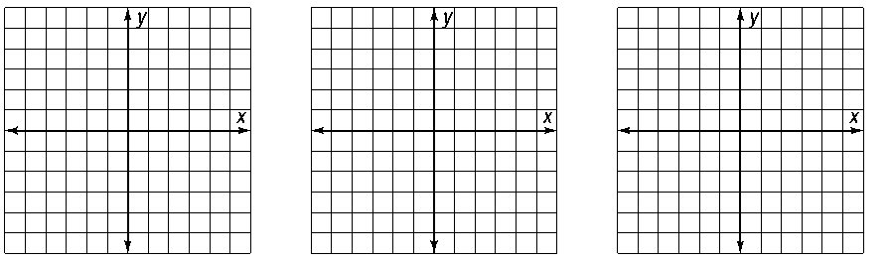**6.** *y* = 3*x* − 4 **7.** *y* = *x* + 5 **8.** *y* = −4*x*

**9.** *y* = $\frac{1}{2}$*x* -1 **10.** *y* = $-\frac{5}{3}$*x* + 2  **11.** *y* = – *x*

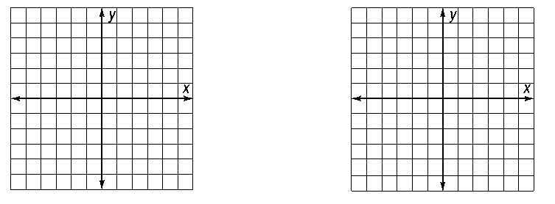

**Use the given information to write an equation for each line.**

**12.** slope 6, *y*-intercept 4 **13.** slope −, *y*-intercept −2

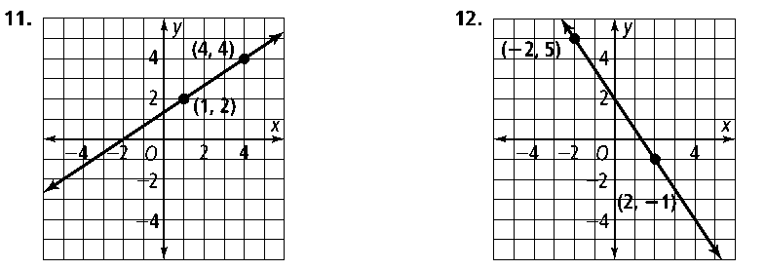**14.** **15.**

**16.** slope -3, passes through (4, -1) **17**. slope $\frac{3}{5}$, passes through (5, 8)

**18.** through (−2, 0) and (3, 10) **19.** through (10, 2) and (2, −2)

**Graph each line.**

**20.** *y* = −4 **21.** *x* = 3 **22.** *y* = 5



**23.** A wireless phone company charges $20 for a basic plan each month plus $0.25/min for each call.

**a.** Write an equation to show how much the company charges, where *x* is the number of minutes used and *y* is the total cost.

**b.** Find the total cost for 300 minutes, 350 minutes, and 400 minutes.