NAME ____________________________
Key Concept | Notes
Slope (m) | 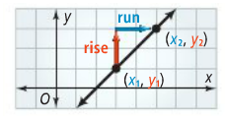  Definition Formula  The ratio of the ____________  change (________) to the  ____________ change (______)  between any two points.  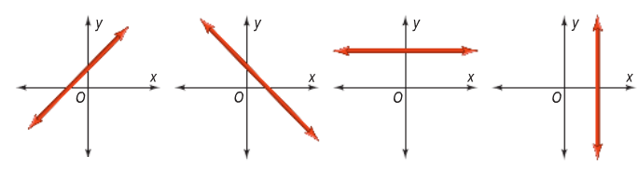
Problem 1 | 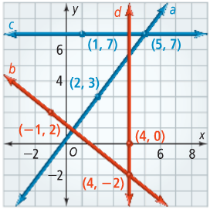  Determine the following slopes:  a. line a b. line b  c. line c d. line d
Linear Equations
Slope-intercept form
Problem 2 | 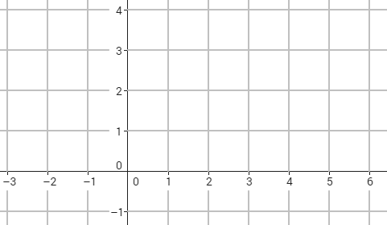  What is the graph of y = $\frac{2}{3}$x + 1?
Writing Equations  of Lines  Problem 3 | A. What is an equation of the line with slope 3 and y-intercept -5?  B. What is an equation of the line through (-1, 5) with slope 2?  C. What is the equation of the line passing through (3, 3) and (4, 7)?
APPLICATION
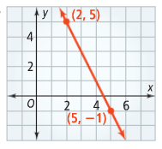
Find the slope of the line passing through the given points.
1. (4, 5) and (6, 15) 2.

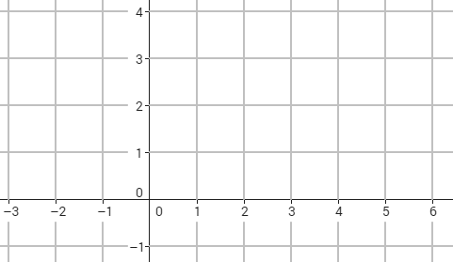
Graph each line.
3. y = -½x + 3
4. x = 3

5. What is an equation of a line with slope 8 and y-intercept 10?

6. What is an equation of the line through (-6, 2) with slope $\frac{2}{3}$?

7. What is an equation of a line passing through (-4, 4) and (2, 10)?

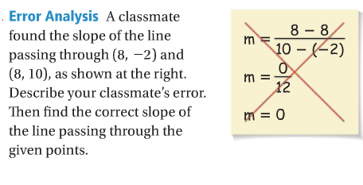
COMPREHENSION
8.

