Name

Class

Date

**Find *m***∠**1.**

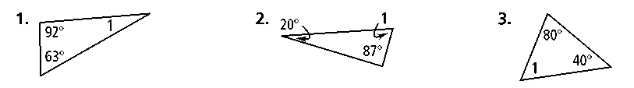**1. 2. 3.**

**Algebra Find the value of each variable.**

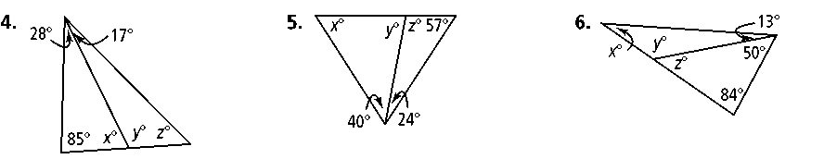**4. 5. 6.**

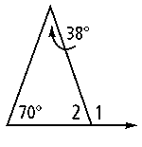**7.** Use the diagram at the right to answer the questions.

**a.** Which angle is an exterior angle?

**b.** What are its remote interior angles?

**c.** Find *m*∠1 and *m*∠2.

**Find the value of the variables and the measures of the angles.**

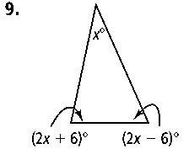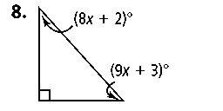**8. 9.**

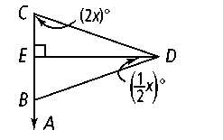**10.** In the figure at the right,  ⊥ and ** bisects ∠*CDB.* Find *m*∠*DBA.*

**11. Reasoning** What is the measure of each angle in an isosceles right triangle? Explain.

**12.** The ratio of the angle measures of the acute angles in a right triangle is   
2 : 3. Find the measures of the acute angles.

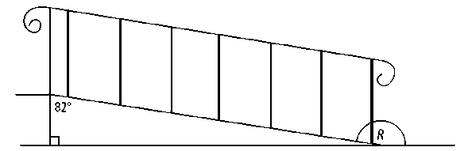

**13.** A ramp built for wheelchairs is shown at right. Find *m∠R.*

**Find each missing angle measure.**

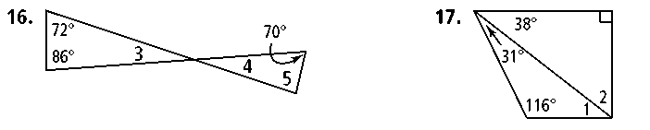 **14. 15.**

**16. Reasoning** Two angles of a triangle measure 53 and 39. What is the measure of the largest exterior angle of the triangle? Explain.

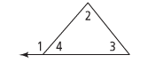**17**. Complete the proof for the Triangle Exterior Angle Theorem.



**Statements** **Reasons**

1. 1.

2. ∠1 and ∠4 are supplementary 2.

3. *m*∠1 + *m*∠4 = 180 3.

4. *m*∠2 + *m*∠3 + *m*∠4 = 180 4.

5. 5. Substitution Property

6. 6.

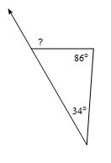**Find the measure of each angle indicated.**

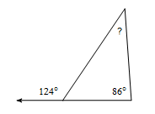

**18.**  **19.**

**Solve for *x*.**

**20.**

