NAME ________________________________
Concept/Main Idea | Notes
Triangle Sum Theorem | 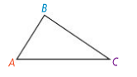
Parallel Postulate | 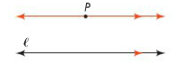
Proof | 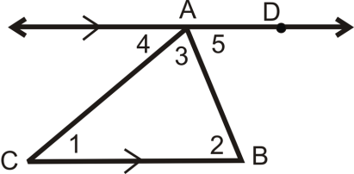  Given: ΔABC  Prove: m∠1 + m∠2 + m∠3 = 180°  Statements Reasons  1. $\overset{⃡}{AD}$ || $\overline{CB}$ 1.  2. m∠4 + m∠3 + m∠5 = 180° 2.  3. m∠4 = m∠1; m∠5 = m∠2 3.  4. m∠1 + m∠3 + m∠2 = 180° 4.
Problem 1 | What are the values of x, y, and z in the diagram?  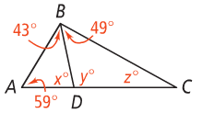
Triangle Exterior Angle Theorem | The measure of each ________________ _______________ of a triangle equals the sum of the measures of its two ____________  _____________________________________.  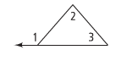
Problem 2 | 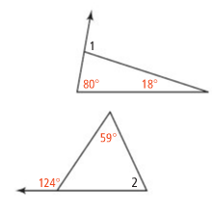  A. What is the measure of ∠1?  B. What is the measure of ∠2?
APPLICATION
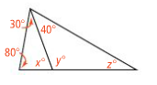
1. Find the m∠1. 2. Find the value of each variable.
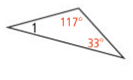

3. Find the m∠2. 4. Solve for x.
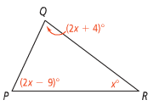
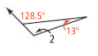

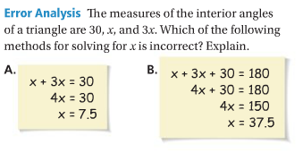
COMPREHENSION
5.

