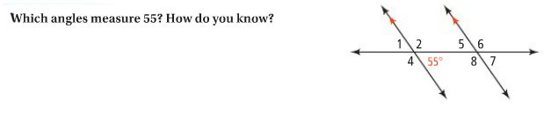
Problem 1

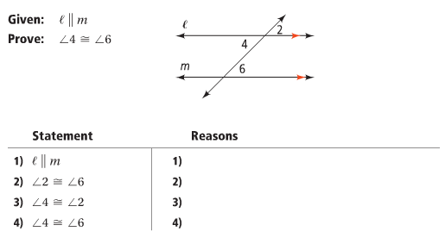
Proof: Alternate Interior Angles Theorem

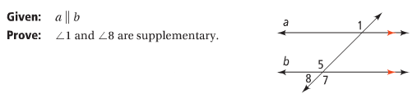
Proof: Same-Side Interior Angles Theorem

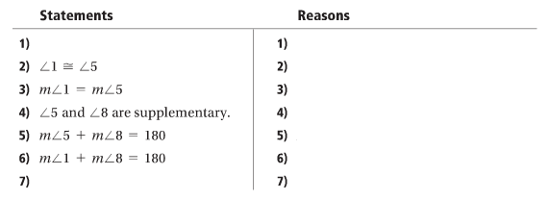

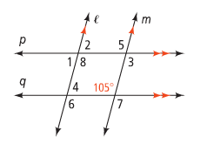
Problem 2
What are the measures of the unknown angles?
Problem 3
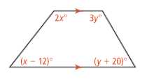
In the figure at right,
- What are the values of x and y?

- What are the measures of the four angles?

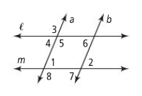
Problem 4
- Which lines are parallel if ∠1 ≅ ∠2? Justify your answer.

- Which lines are parallel if ∠6 ≅ ∠7? Justify your answer.

Proof: Converse of the Alternate Interior Angles Theorem
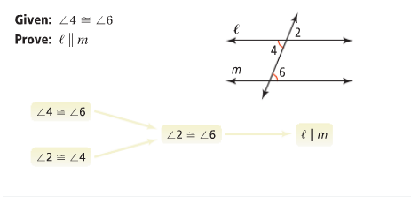

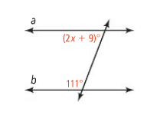
Problem 5
What is the value for x for which line a | | line b?

