Name _____________________________ Class ______________ Date _______________
Identify all the numbered angles that are congruent to the given angle. Justify your answers.
- 2.

Find m∠∠1 and m∠∠2. Justify each answer.
3. 4.

Algebra Find the value of x and y. Then find the measure of each labeled angle.
5. 6.

7. 8.

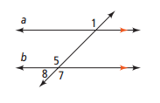
9. Complete the two-column proof for the Alternate Exterior Angle Theorem.
Given: a || b
Prove: ∠1 ≅ ∠ 7

Statements Reasons
1) 1)
2) 2) Corresponding ∠s Postulate
3) 3) Vertical ∠s Theorem
4) 4)
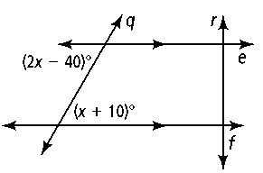
10. Error Analysis. Which solution for the figure at right is incorrect? Explain.
2x − 40 = x + 10 2x − 40 + (x + 10) = 180
x − 40 = 10 3x − 30 = 180
x = 50 3x = 210
x = 70
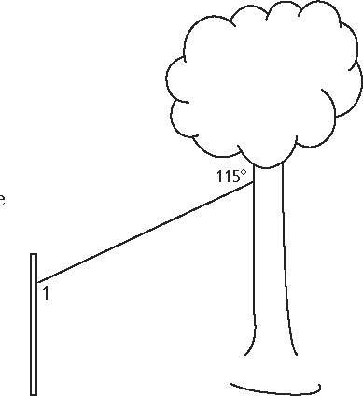
11. A zip line consists of a pulley attached to a cable that is strung at an angle between two objects. In the zip line at the right, one end of the cable is attached to a tree. The other end is attached to a post parallel to the tree. What is the measure of ∠∠1? What type of angle pair do ∠1 and the given angle represent?

Which lines or segments are parallel? Justify your answer.
12. 13. 14.

15. Complete the flow proof. (Converse of the Same-Side Exterior Angle Theorem)
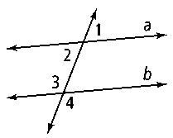
Given: ∠1 and ∠4 are supplementary
Prove:
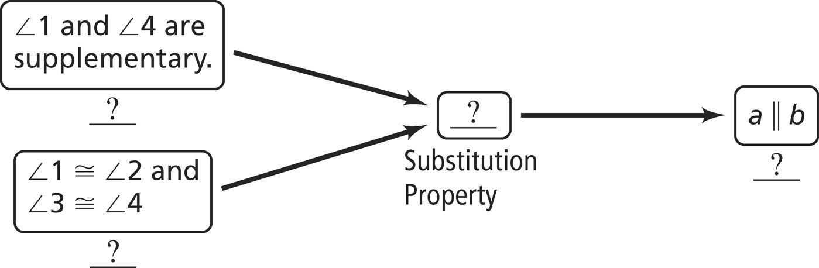

Algebra Determine the value of x for which r ║ s. Then find the measure of each labeled angle.
16. 17. 18.

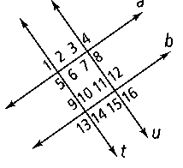
Use the given information to determine which lines, if any, are parallel. Justify each conclusion with a theorem or postulate.
19. ∠∠11 is supplementary to ∠∠10. 20. ∠∠6 ≅ ∠∠9

21. ∠∠13 is supplementary to ∠∠14. 22. ∠∠13 ≅ ∠∠15

In Exercises 23 and 24, a, b, and c are distinct lines in the same plane. For each combination of relationships, tell how a and c relate. Justify your answer.
23. a ⊥ b; b ⊥ c 24. a ⊥ b; b || c

