Key Concepts | Notes
Parallel Lines |  | 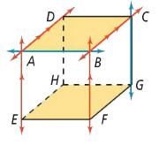
Parallel Planes
Skew Lines
Perpendicular Lines | 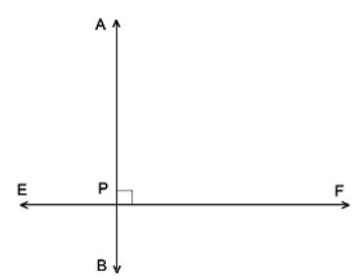
Problem 1 | In the figure, assume that lines and planes that appear to be parallel are parallel.  A. Which segments are parallel to $\overline{AB}$?  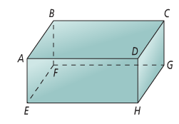  B. Which segments are skew to $\overline{CD}$?  C. What are two pairs of parallel planes?  D. What are two segments parallel to plane BCGF?
Angles Formed by Transversals
Transversal
Alternate Interior Angles |  | 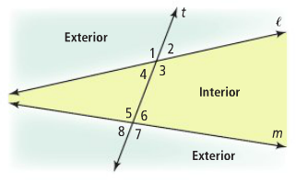
Same-Side Interior Angles
Alternate Exterior Angles
Same-Side Exterior Angles
Corresponding Angles
Problem 2 | 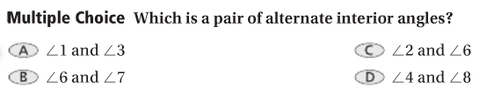  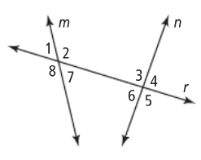  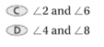

APPLICATION
Use the diagram to name each of the following.
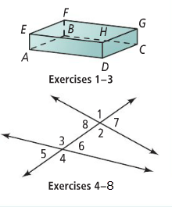
Lines and planes that appear to be parallel are parallel.

1. all lines parallel to $\overset{⃡}{AB}$

2. all lines skew to $\overset{⃡}{CG}$

3. a plane parallel to plane CDHG

4. both pairs of alternate interior angles

5. both pairs of same-side interior angles

6. four pairs of corresponding angles

7. both pairs of alternate exterior angles

8. both pairs of same-side exterior angles

COMPREHENSION
