Name ___________________________________ www.danielselements.weebly.com
Key Concepts | Notes
Theorem
Deductive reasoning
Vertical Angles Theorem | 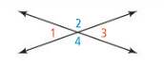  Vertical angles are _______________.  ∠1 ≅ ∠3 and ∠2 ≅ ∠4
PROOF | 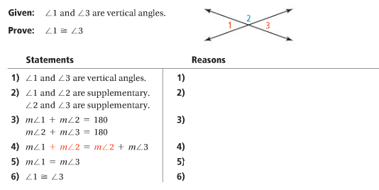
Using the Vertical  Angles Theorem | 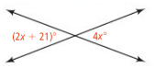  What is the value of x?
Proof Using the Vertical Angles Theorem | 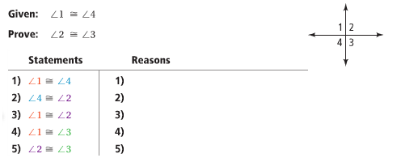
Congruent Supplements Theorem | It two angles are _______________________ of the same angle (or of congruent angles), then the two angles are __________________.
Congruent Complements Theorem | It two angles are _______________________ of the same angle (or of congruent angles), then the two angles are __________________.
Theorem | If two angles are _________________ and _________________________, then each is a __________ _______________.
APPLICATION
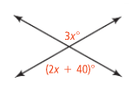
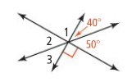
1. What are the measures of ∠1, ∠2, and ∠3? 2. What is the value of x?

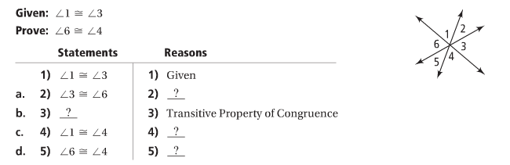
3. Complete the following proof by filling in the blanks.

COMPREHENSION
4. Your friend knows that ∠1 and ∠2 are complementary and that ∠1 and ∠3 are complementary. He concludes that ∠2 and ∠3 must be complementary. What is the error in his reasoning?

