Name ___________________________________ www.danielselements.weebly.com
Key Concepts | Notes
Properties of Equality | Let a, b, and c be any real numbers.
Addition Property | If a = b, then __________________
Subtraction Property | If a = b, then __________________
Multiplication Property | If a = b, then __________________
Division Property | If a = b and _________, then __________________
Reflexive Property
Symmetric Property | If a = b, then __________________
Transitive Property | If a = b and ________, then __________________
Substitution Property | If a = b, then __________________
Distributive Property
PROBLEM | 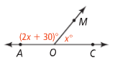  What is the value of x? Justify each step.
Properties of Congruence
Reflexive Property
Symmetric Property
Transitive Property
PROBLEM | What is the name of the property of equality or congruence that justifies going from the first statement to the second statement?  a. 2x + 9 = 19 b. ∠O ≅ ∠W and ∠W ≅ ∠L c. m∠E = m∠T  2x = 10 ∠O ≅ ∠L m∠T = m∠E
Two-Column Proof  PROBLEM | 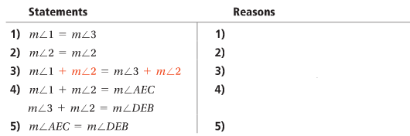
APPLICATION
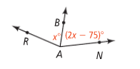
- What is the value of x? Justify each step.
Given: $\vec{AB}$ bisects ∠RAN

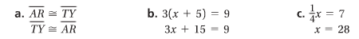
- What is the name of the property of equality or congruence that justifies going from the first statement to the second statement?

- Complete the reasons in the given two-column proof.

Statements Reasons
- $\overline{AB}$ ≅ $\overline{CD}$ 1)
- $AB=CD$ 2) Definition of ≅
- $BC=BC$ 3)
- $AB+BC=BC+CD$ 4)
- $AB+BC=AC$ 5)
BC + CD = BD
- AC = BD 6)
- $\overline{AC}$ ≅ $\overline{BD}$ 7) Definition of ≅

