Key Concept | Notes
Secant | 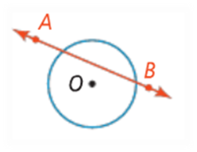
Angles formed by the intersection of…
1) Two Chords
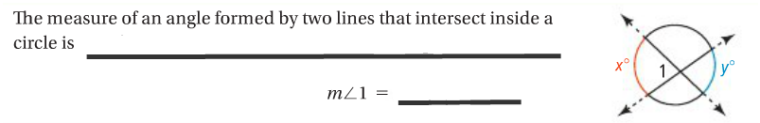

2) a. Two Secants b. Secant & Tangent c. Two Tangents
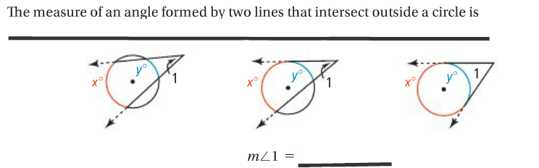

Problem 1 | What is the value of each variable?
Problem 2 | A satellite in a geostationary orbit above Earth’s equator has a viewing angle of Earth formed by the two tangents to the equator. The viewing angle is about 17.5°. What is the measure of the arc of Earth that is viewed from the satellite?  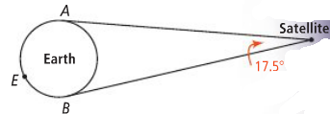
Segments formed by the intersection of…
1. Two Chords  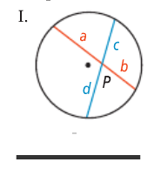 |  | 2. Two Secants  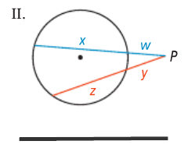 | 3. Secant & Tangent  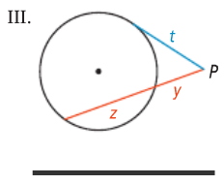
Problem 2 | Find the value of each variable.
APPLICATION
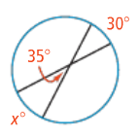
What is the value of each variable?
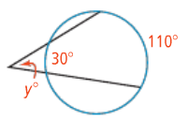
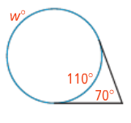
1. 2. 3.

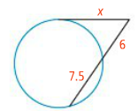
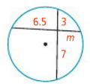
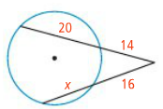
4. 5. 6.

