Key Concept | Notes
Inscribed Angles | Inscribed angles –  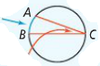  Intercepted arcs –
Inscribed Angle Theorem | 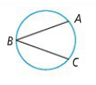
Problem 1 | What are the values of a and b?  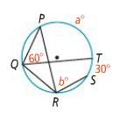
Corollaries to the Inscribed Angle Theorem | 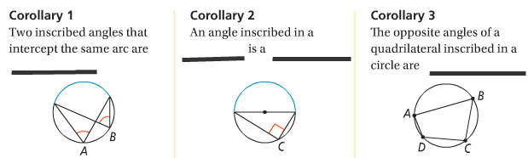
Problem 2 | 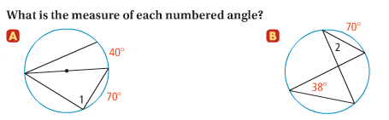
Tangent – Chord Theorem | 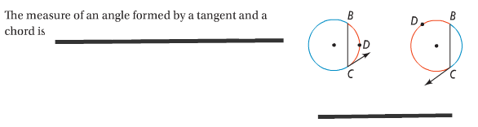
Problem 3 | 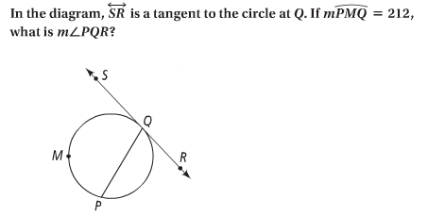

APPLICATION

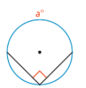
Find the value of each variable.
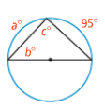
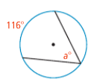
1. 2. 3.

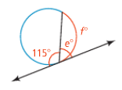
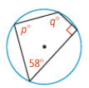
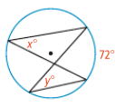
4. 5. 6.

