Key Concept | Notes
Tangent line | 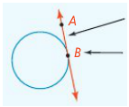
Tangent-Radius Theorem | If a line is _______________ to a _______________, then the line is ______________________ to the radius at the point of ________________.  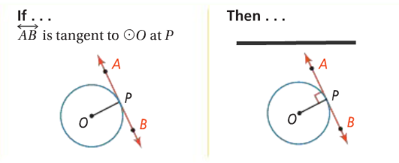
Problem 1 | 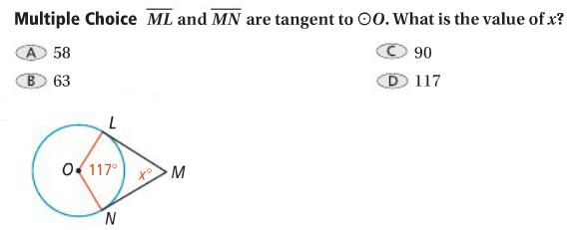
Problem 2 | What is the distance to the horizon that a person can see on a clear day from an airplane 2 mi above the Earth? Earth’s radius is about 4000 mi.  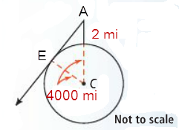
Converse of the Tangent-Radius Theorem | If a line in the plane of a _____________ is _______________________ to a radius at its endpoint on the __________________, then the line is __________________ to the ________________.  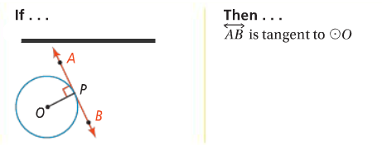
Problem 3 | 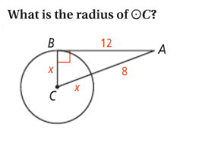
Problem 4 | 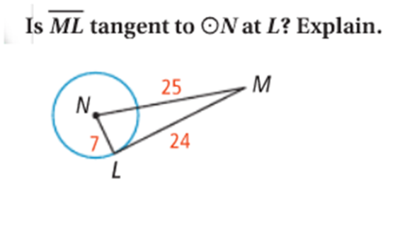
Theorem | If two _________________ segments to a ______________ share a common endpoint outside the _____________, then the two segments are ___________________.  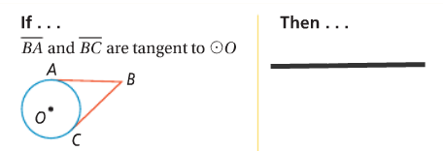
Problem 5 | Circle O is inscribed in ΔABC. What is the perimeter of ΔABC?  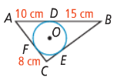
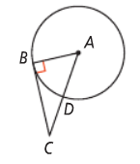
APPLICATION
1. If m∠A = 58, what is m∠ACB? 2. If BC = 8 and DC = 4, what is the radius?

3. If AC = 12 and BC = 9, what is the radius?

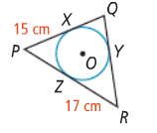
4. Circle O is inscribed in ΔPQR, which has a perimeter of 88 cm. What is the length of $\overline{QY}$?

