Key Concept | Notes
Sphere | 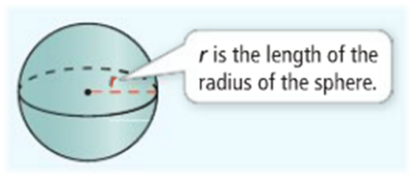  Radius –  Diameter –
Surface Area | 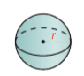
Problem 1 | What is the surface area of the sphere in terms of π?  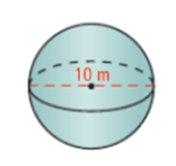
Problem 2
Volume | 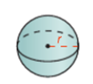
Problem 3 | What is the volume of the sphere in terms of π?  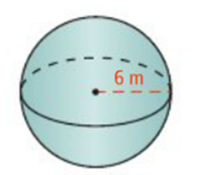
Problem 4 | The volume of a sphere is 5000 m³. What is its surface area to the nearest square meter?
APPLICATION
The diameter of a sphere is 12 ft.
1. What is its surface area in terms of π? 2. What is its volume in terms of π?

3. The volume of a sphere is 80π cm³. What is the surface area rounded to the nearest tenth?

COMPREHENSION (2 POINTS!)
Your classmate claims that if you double the radius of a sphere, its surface area and volume will quadruple. What is your classmate’s error? EXPLAIN.

