Key Concept | Notes
Volume of a Pyramid | 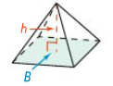
Problem 1 | Find the volume of the square pyramid.  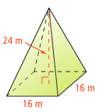
Problem 2 | 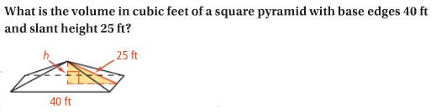
Volume of a Cone | 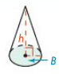
Problem 3 | The covering on a tepee rests on poles that come together like concurrent lines. The resulting structure approximates a cone. If the tepee is 12 ft high with a base diameter of 14 ft, what is its approximate volume?
Problem 4 | What is the volume of the oblique cone? Give your answer in terms of π.  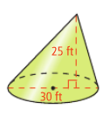
APPLICATION
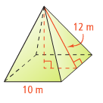
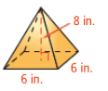
Find the volume of the square pyramid. Round to the nearest tenth, if necessary.
1. 2.

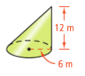
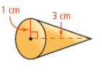
Find the volume of the cone. Leave answers in terms of π.
3. 4.

