Key Concept | Notes
Volume formulas | Rectangular Prism Cube Prism (any shape base)  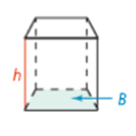  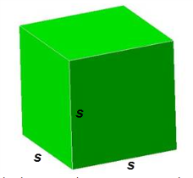  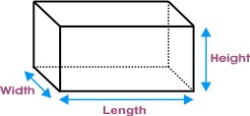  V = V = V =
Problem 1 | What is the volume of the rectangular prism?  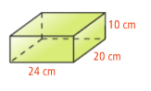
Problem 2 | What is the volume of the triangular prism? Round your answer to the nearest tenth.  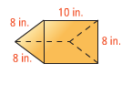
Volume of a Cylinder | 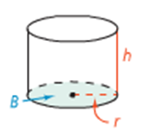
Problem 3 | What is the volume of the cylinder in terms of π?  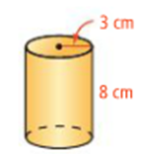
Problem 4 | 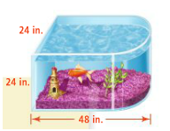  What is the approximate volume of the bullnose aquarium to the nearest cubic inch?

APPLICATION
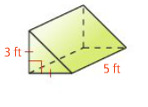
What is the volume of each figure? If necessary, round to the nearest tenth. Leave answers in terms of π for cylinders.
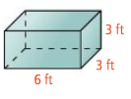
1. 2.

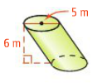
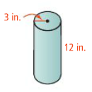
3. 4.

