Key Concept | Notes
Pyramid | 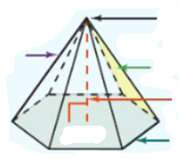
Heights of Pyramid | 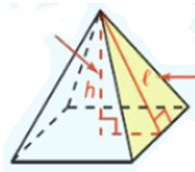  Height –  Slant height –
Lateral & Surface Area | LA = SA =
Problem 1 | What is the surface area of the hexagonal pyramid?  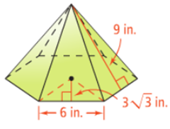
Problem 2 | What is the lateral area of the square pyramid? Round to the nearest square meter.  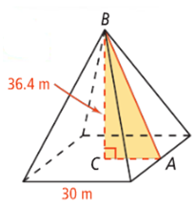
Cone | 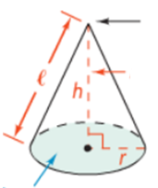
Lateral & Surface Area | LA = SA =
Problem 3 | What is the surface area of the cone in terms of π?  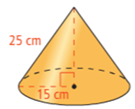
Problem 4 | How much filter paper do you need to line the funnel?  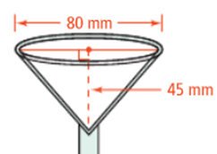
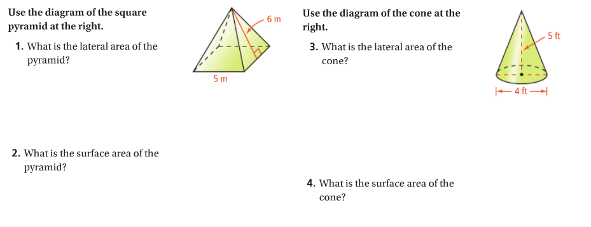
APPLICATION

