What you need to know… | - The ___________ of a ___________ polygon is related to the ______________ from the _____________ to a ___________.  - The ___________ of a ___________ ____________ is the distance from the center to a ____________.  - The ______________ is the perpendicular distance from the center to a side.  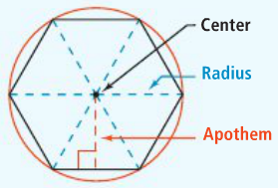
Area of a regular polygon | 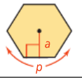  A=
Problem 1:  Find the area of the regular decagon. | 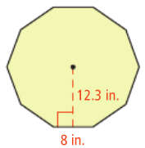
Problem 2:  Find the area of the regular hexagon. Round to the nearest millimeter. | 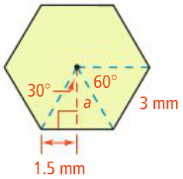

Application
Find the perimeter and area of each regular polygon. Leave your answers in simplest radical form.
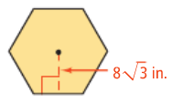
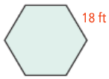
1. 2.

3. Find the perimeter and area of the regular pentagon. (Hint: you will need to use trigonometry)
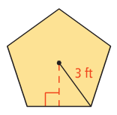

4. Comprehension: Why is the radius of a regular polygon greater than the apothem? (hint: think about what you know about right triangles)

