Area of a trapezoid | 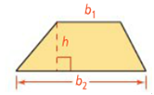  A=
Problem 1:  What is the approximate area of Nevada? | 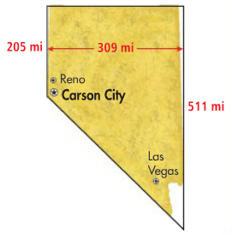
Area of a Rhombus or Kite | 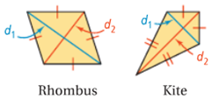  A=  What information do you need in order to find the area of a rhombus or kite?
Problem 2:  What is the area of KLMN? | 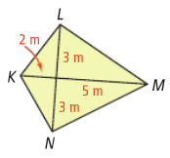
Problem 3:  Find the area of the rhombus. | 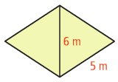  How did we know $d_{1}$ was 8m without calculating anything?

Application
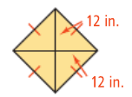
Find the area of each figure.
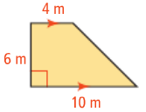
1. 2.

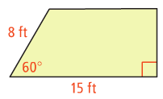
3. Find the area and perimeter of the trapezoid. Round to the nearest tenth.

4. Find the area of the kite.
4$\sqrt{3}$
4$\sqrt{3}$
