Perimeter | The ________________ of a _______________ is the sum of the ______________ of the sides.
Area | The ________ of a polygon is the number of ___________ ___________ it encloses.
Square | P=  A=
Triangle | P=  A=
Rectangle | P=  A=
Parallelogram | P=  A=
Problem 1 | What is the perimeter and area of the parallelogram?  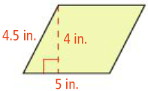
Problem2 | 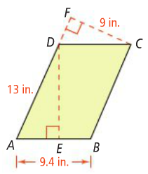  What is the value of DE to the nearest tenth?
Problem3 | 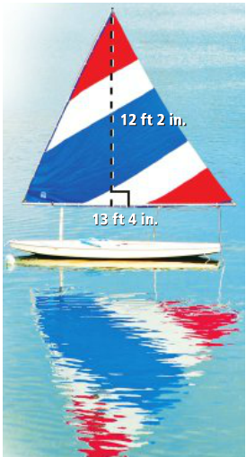  If you wanted to make a triangular sail like the one shown, how many square feet of material would you need?
Application:
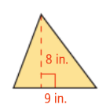
Find the area of each figure.
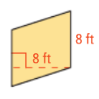
1. 2.

3. What is the area of the triangle? 4. Find the value of h.
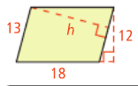
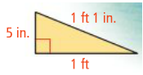

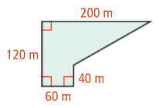
5. Find the are of the figure.

