Name ___________________________________ www.danielselements.weebly.com
Key Concepts | Notes
GeoGebra | http://www.geogebra.org  Experiment with creating points, lines, segments, angles, etc.
Perpendicular | 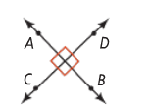
Perpendicular bisector | 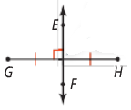
Midpoint formula | On a number line In the coordinate plane
Problem 1 | a. $\overline{AB}$ has endpoints at -4 and 9. What is the coordinate at its midpoint?  b. $\overline{EF}$ has endpoints E(7, 5) and F(2, -4). What are the coordinates of its midpoint M?
Problem 2 | The midpoint of $\overline{CD}$ is M(-2, 1). One endpoint is C(-5, 7). What are the coordinates of the other endpoint D?
Distance formula

Problem 3 | What is the distance between U(-7, 5) and V(4, -3)? Round to the nearest tenth.
APPLICATION
1. $\overline{RS}$ has endpoints R(2, 4) and S(-1, 7). What are the coordinates of its midpoint M?
2. The midpoint of $\overline{BC}$ is (5, -2). One endpoint is B(3, 4). What are the coordinates of endpoint C?
3. What is the distance between points K(-9, 8) and L(-6, 0)?
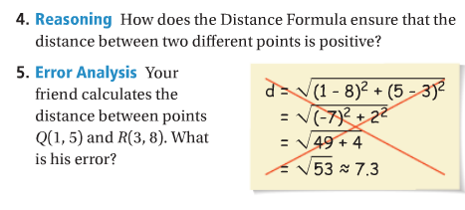
COMPREHENSION

