Name ___________________________________
Key Concepts | Notes
Distance

Ruler Postulate | 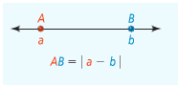  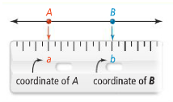
Problem 1  Find the length of each segment | 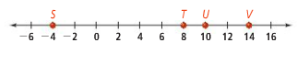  - ST b. UV c. SV
Segment Addition Postulate | If three points A, B, and C are _______________ and B is between A and C, then ____ + ____ = _____.
Problem 2  If JL = 120, what are JK and KL? | 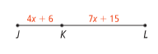
Congruent segments | If ____ _____________ have the same length, then the _____________ are _____________ ________________.  Symbol:
Midpoint | 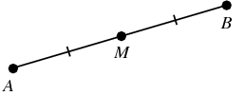
Segment bisector | 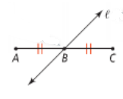
Problem 3
Point Q is the midpoint of $\overline{PR}$. What are PQ, QR, and PR?

APPLICATION
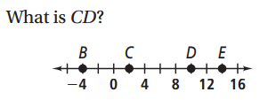
1.

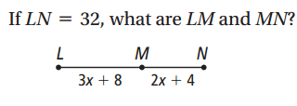
2.

3. Point S is the midpoint of $\overline{RT}$. What are RS, ST, and RT?
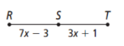

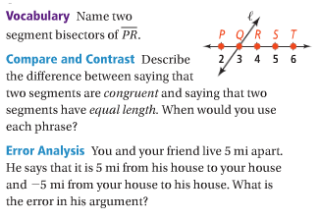
COMPREHENSION

