Name ________________________

|  |  |
| --- | --- |
| **Key Concepts** | **Notes** |
|  |  |
| Geometry |
|  |
| Euclid |  |
|  |
|  |
|  |
|  |
| The Elements |  |
|  |
| Undefined Terms |  |
|  |
| Point | H:\SY 14-15\Geometry\Ch 1\points.pngDESCRIPTION DIAGRAM NAMING      H:\SY 14-15\Geometry\Ch 1\line.png |
|  |
|  |
|  |
|  |
| Line |  |
|  |
|  |
|  |
|  |
| Plane | * H:\SY 14-15\Geometry\Ch 1\plane3.gif |
|  |
|  |
|  |
|  |
| Defined Terms |  |
|  |
|  |
| Segment | DEFINITION DIAGRAM NAMING |
|  |
|  |
|  |
|  |
|  |

|  |  |
| --- | --- |
| Ray  Opposite rays  Postulates  (AKA Axioms)  1)  2)  3)  4) | DEFINITION DIAGRAM NAMING |
|  |
|  |
| Through any ____ ________  there is exactly _____ _______. |
| The _________________ of _______  __________ is a _____________ |
| The _________________ of _______  __________ is a _____________ |
| Through any ________ __________________  _________ there is exactly ______ __________. |
| APPLICATION | |
| COMPREHENSION | |

PRACTICE

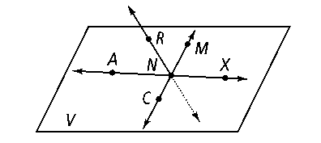**Use the figure below for Exercises 1–8. Note that pierces the plane at *N****.* **It is not coplanar with *V*.**

**1.** Name two segments shown in the figure.

**2.** What is the intersection of ****and *****?*

**3.** Name three collinear points.

**4.** What are two other ways to name plane *V?*

**5.** Are points *R, N, M,* and *X* coplanar?

**6.** Name two rays shown in the figure.

**7.** Name the pair of opposite rays with endpoint *N.*

**8.** How many lines are shown in the drawing?

**For Exercises 9–14, determine whether each statement is *always, sometimes,* or *never* true.**

**9. **and  are the same ray.

**10.** ** and **are opposite rays.

**11.** A plane contains only three points.

**12.** Three noncollinear points are contained in only one plane.

**13.** If ****lies in plane *X,* point *G* lies in plane *X.*

**14.** If three points are coplanar, they are collinear.

**15. Reasoning** Is it possible for one ray to be shorter in length than another? Explain.

**16. Reasoning** Point *F* lies on ****and point *M* lies on *****.* If *F*, *E,* and *M* are collinear, what must be true of these rays?

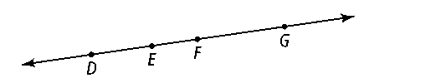

**17.** How many segments can be named from the figure at right?

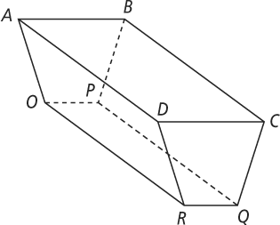**Use the figure at the right for Exercises 18–26.   
Name the intersection of each pair of planes or lines.**

**18.** planes *ABP* and *BCD*

**19. **and 

**20.** planes *ADR* and *DCQ*

**21.** planes *BCD* and *BCQ*

**22. **and 

**Name two planes that intersect in the given line.**

**23. ****24. ****25. ****26. **